**October 12, 2015**

Acrylic/Plexiglas Bending

1. Use “Hot Air Station” to melt the acrylic to bend it on an edge
2. **Always secure the acrylic using a clamp and apply the hot air on an edge only in to and fro fashion**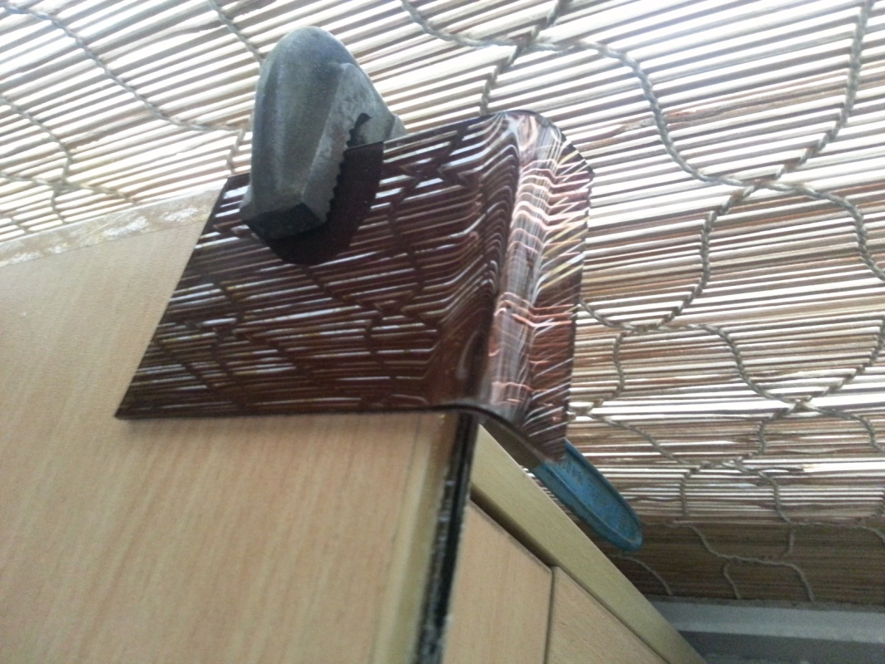
3. While applying the hot air, bend the acrylic. After bending,
   1. **HOLD IN PLACE FOR SOMETIME TO ALLOW ACRLYIC TO COOL AND SET**
   2. **ALSO USE THIN NOZZLE FOR DIRECTED AIR.**

|  |  |  |
| --- | --- | --- |
| **Acrylic Width** | **Temperature (Celsius)** | **Fan Speed** |
| 2mm | 180 C | 3 |
| 3mm | 250 C | 5 |

**NOTE : IF YOU HAVE TO MAKE HOLES/CUT IN BENT ACRYLIC MAKE THEM AFTER BENDING AS THEY MIGHT DEFORM DURING BENDING AND ALSO IT’S VERY HARD TO GAUGE THE FINAL POSITION OF THEM AFTER BENDING. SO ITS BETTER TO DRILL AFTER BENDING**